Embark/Tulsa Chapter OSCPA CPE Online, August 20, 2020
Presenters: Robby Sundberg & Caroline Willet, Embark

Robert “Robby” Sundberg, CPA, Embark Senior Manager

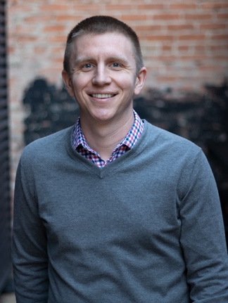

I grew up in Fort Worth and earned my Bachelor’s and Master’s in Accounting from the University of Texas at Austin. After college, I began my career at Deloitte in the Dallas audit practice where, for nearly three years, I served a variety of clients and industries. I then spent over three years in the internal audit group at Verizon where I led multidisciplinary teams in the execution of highly visible operational, financial, and SOX audits. Most recently, I was at Toyota Financial Services where I served as Assistant Controller for a Toyota subsidiary. At TFS, I was responsible for all aspects of accounting and financial reporting related to an insurance services company.

At Embark, I use my love for constant learning, building relationships, and solving problems, and my diverse professional experiences, to serve our clients excellently.

Outside of work, I enjoy spending time with my family and friends, playing basketball, watching just about any sporting event (but especially the Longhorns and Cowboys), and good coffee and food. Finally, I love to travel the world and experience new places and cultures.

Caroline Willet, CPA, Embark Manager


I grew up in Rockwall, Texas, and eventually moved the short distance to Dallas to pursue a BBA in Accounting from SMU. After graduating, I ventured down to Austin to be a Longhorn and got my Master’s in Accounting from The University of Texas. I moved back to Dallas to begin my career at PwC in the private company services audit group, where I primarily served clients within the consumer products and technology industries. During my time in Big-4 audit, I learned how businesses function at a granular level, honed my technical accounting and project management skills, and served as a resource for clients on time-sensitive accounting and financial reporting issues.

Through my experience, I’ve learned the value of authentic relationships and effective problem-solving in order to help both clients and my teams. I joined Embark because I am enthusiastic about finding solutions to important problems at a more “hands-on” level and helping clients succeed.

When I’m not at work, I love all things music, tending to my novice garden, and enjoying the best tacos and beer Texas has to offer. You can also frequently find me enjoying a great TV show with those I love (including my two rescue cats and a cattle dog named Barb).

